**NAME………………………………………………INDEX NO:.…ADM NO………**

**SCHOOL**……………………………………**…SIGNATURE**…….…. **DATE**………

**233/1**

**CHEMISTRY PAPER 1 (THEORY)**

**THEORY**

**TERM 1**

**2 HOURS**

FORM 4

**Kenya Certificate of Secondary Education (K.C.S.E)**

***INSTRUCTIONS TO CANDIDATES***

* Write your name and index in the **spaces** provided.
* Sign and write the date the examination is done.
* Answer **all** the questions in the spaces provided.
* Mathematical tables and **electronic calculators** may be used.
* ALL workings **MUST** be clearly shown where necessary.
* **This paper contains 11 printed pages.**
* **Candidates should check the question paper to ascertain that all pages are printed as indicated and that no question is missing.**
* **Candidates should answer questions in English.**

**For Examiner’s Use Only**

|  |  |  |
| --- | --- | --- |
| **Question** | **Maximum score** | **Candidates score** |
| 1-27 | 80 |  |

1. The electronic configurations for elements represented by letters **A**, **B**, **C** and **D** are

**A** 2.8.6 **B**. 2.8.2. **C**.2.8.1. **D**.2.8.8

(a) Select the element which forms:

i) A double charged cation (1 mark)

………………………………………………………………………………………………………

ii) A soluble carbonate (1 mark)

………………………………………………………………………………………………………

(b) Which element has the largest atomic radius  (1 mark)

………………………………………………………………………………………………………

1. An element **R** has atomic number 3, relative atomic mass 6.94 and consist of two isotopes of mass numbers 6 and 7.
2. What is the mass number of the more abundant isotope of **R**? Give a reason for your answer. (2 marks)

………………………………………………………………………………………………………

1. Complete the following table. (1 mark)

|  |  |  |
| --- | --- | --- |
| **Element** | **Number of neutrons** | **Number of electrons** |
| **R** |  |  |

1. R COO- Na+ and RC6H5 OSO3 -Na+ represent two cleaning agents where R is a long hydrocarbon chain.
2. Which of the cleansing agents is suitable for use with hard water? (1 mark)

…………………………………………………………………………………………………

…………………………………………………………………………………………………

1. Write the formula of an ion than causes:
2. Water hardness (1 mark)

…………………………………………………………………………………………………

1. Permanent water hardness (1 mark)

…………………………………………………………………………………………………

1. In an experiment, a student put equal volumes of mixtures of ethanoic acid in water and ethanoic acid in hexane in two test-tubes as shown below. In each test tube, equal amounts of solid sodium hydrogen carbonate were added.

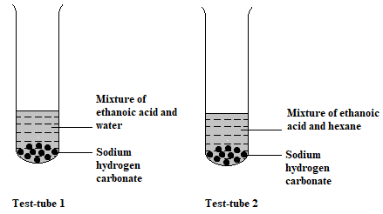

a) State the observation which was made in each test-tube (1 mark)

Test tube 1

…………………………………………………………………………………………………

Test tube 2

…………………………………………………………………………………………………

b) Explain the observations in (a) above (2 marks)

…………………………………………………………………………………………………

…………………………………………………………………………………………………

…………………………………………………………………………………………………

1. Bromine reacts with ethane as shown below

C2H6 + Br2 C2H5Br + HBr.

(a) What condition is necessary for this reaction to occur? (1 mark)

…………………………………………………………………………………………………

(b) Identify the bonds which are broken and those that are formed. (2 marks)

…………………………………………………………………………………………………

…………………………………………………………………………………………………

…………………………………………………………………………………………………

1. Draw a well labelled diagram of the non-luminous flame (3 marks)
2. In an experiment 20cm3 of 0.1 M sulphuric (VI) acid were reacted with 20cm3 of 0.1 M sodium hydroxide.
   * + 1. Write in equation of the reaction that took place. (1 mark)

…………………………………………………………………………………………………

* + - 1. State the observations that were made when both red and blue litmus papers were dropped into the mixture. (1 mark)

…………………………………………………………………………………………………

…………………………………………………………………………………………………

* + - 1. Give a reason for your answer in (a) above (1 mark)

…………………………………………………………………………………………………

1. The diagram below represents a paper chromatogram for three brands of juices suspected to contain banned food colourings.

**K**

**L**

**M**

x

x

x

**Brand of juice**

The results showed the presence of banned food colourings in **L** and **M** only. On the same diagram:

1. Circle the spots which show the banned food colourings (2 marks)
2. Show solvent front. (1 mark)
3. A Compound whose general formula is M(OH)3 reacts as shown by the equation.

**M(OH)3 (q) + OH- (aq) M(OH) –4(aq)**

**M(OH) 3(q) + 3H+ (aq) M3+ (aq) + 3H2O(l)**

(a) What name is given to compounds which behave like M(OH)3 in the two reactions. (1 mark)

…………………………………………………………………………………………………

(b) Name **two** elements whose hydroxides behave like that of M. (2 marks)

…………………………………………………………………………………………………

…………………………………………………………………………………………………

1. A compound contains 82.75% carbon and the rest is Hydrogen. (C=12, H=1)
2. **Determine** its empirical formula. (2 marks)

…………………………………………………………………………………………………

…………………………………………………………………………………………………

…………………………………………………………………………………………………

…………………………………………………………………………………………………

1. **Determine** the molecular formula if its molecular mass is 58. (1 mark)

…………………………………………………………………………………………………

…………………………………………………………………………………………………

…………………………………………………………………………………………………

1. A form four student wanted to determine the solubility of potassium nitrate. He obtained the following results.

**Mass of evaporating dish = 15.13g**

**Mass of evaporating dish and solution = 36.51g**

**Mass of evaporating dish and salt = 19.41g**

Use the information above to calculate the solubility of potassium nitrate. (3 marks)

………………………………………………………………………………………………….……………..……………………………………………………………………………………

…………………………..……………………………………………………………………………………..……………………………………………………………………………………

1. Filtration is carried out in the apparatus shown below.

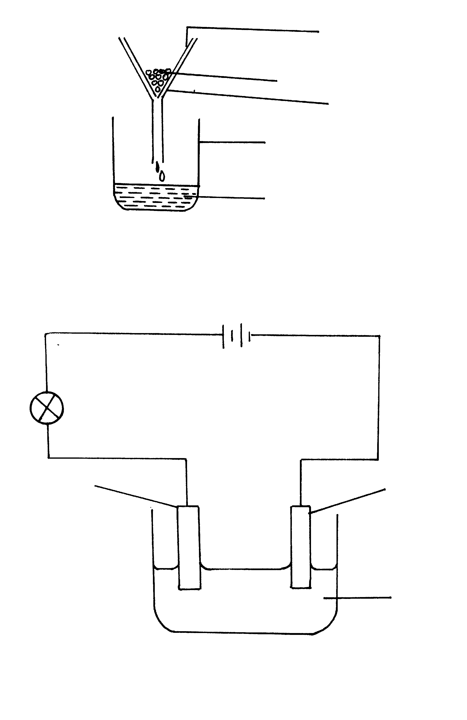

Filter paper

X

Funnel

Beaker

Y

1. Name X and Y (2 marks)

………………………………………………………………………………………………….……………..……………………………………………………………………………………

1. State one application of filtration (1 mark)

………………………………………………………………………………………………….……………..……………………………………………………………………………………

1. a) State Boyle’s law (1 mark)

………………………………………………………………………………………………….

……………..……………………………………………………………………………………

b) A gas occupies a volume of 80dm3 at s.t.p. At what pressure will its volume be doubled if the temperature rises by 105℃? (At s.t.p temperature = 0℃, pressure = 760mmHg) (2 marks)

………………………………………………………………………………………………….……………..……………………………………………………………………………………

…………………………..……………………………………………………………………………………..……………………………………………………………………………………

1. Consider the reaction below.

**Alkanol + Alkanoic acid Ester + water**

**a)** Give the name of the process represented by the above reaction. (1 mark)

………………………………………………………………………………………………

**b)** Name the catalyst which is usually used in the above reaction. (1 mark) ………………………………………………………………………………………………

**c)** State the observation made during the reaction of alkanols and alkanoic acids. (1 mk)

………………………………………………………………………………………………

**15.** Hydrogen sulphide gas was lighted in a gas jar of air using the arrangement below.

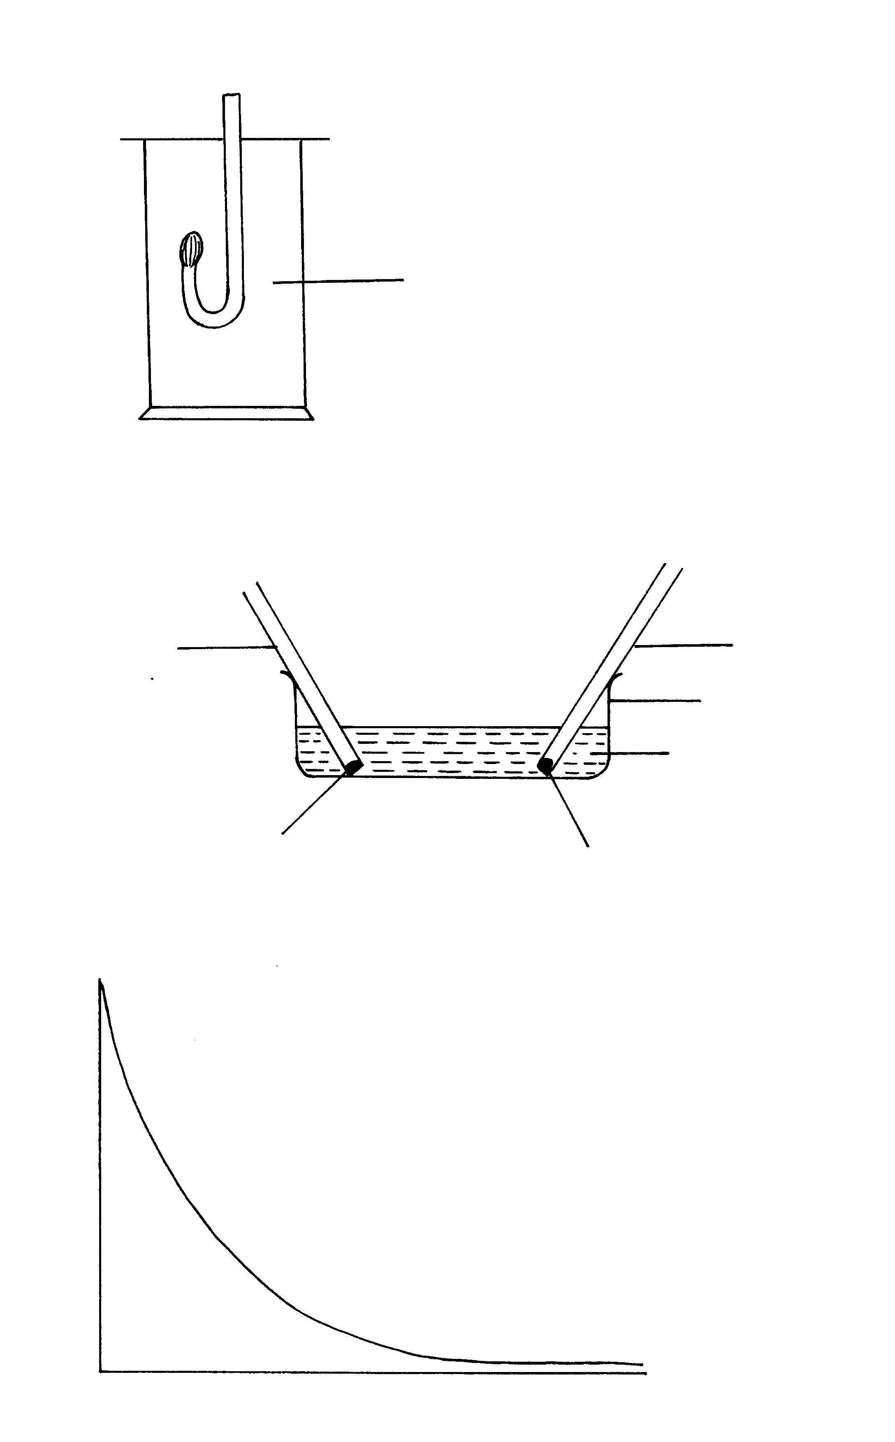

Hydrogen sulphide

a) Write an equation for combustion of hydrogen sulphide gas. (1 mark) ………………………………………………………………………………………………………………………………………………………………………………………………

b) State what is observed if the product is passed through acidified potassium dichromate (VI) solution. (1 mark) ………………………………………………………………………………………………………………………………………………………………………………………………

16. A set-up to investigate electrical conductivity of substances was assembled as shown below.

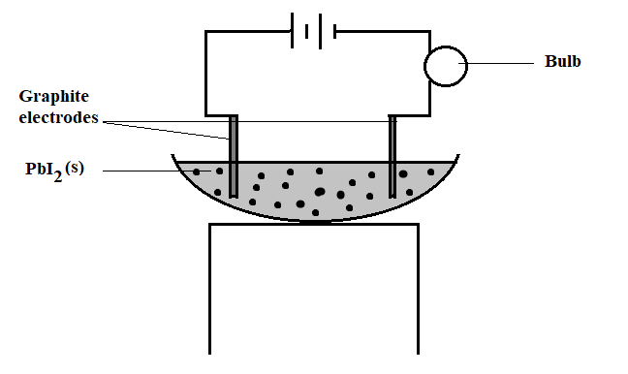

The bulb did not light.

(a) What was missing in the set-up? (1 mark)

………………………………………………………………………………………………

(b) The bulb lit when the omission was corrected. Explain. (1 mark)

………………………………………………………………………………………………………………………………………………………………………………………………

1. State one application of electrolysis. (1 mark)

………………………………………………………………………………………………………………………………………………………………………………………………

1. Steam is passed over heated iron filings in a combustion tube.

(a) Name the two products of this reaction. (2 mark)

………………………………………………………………………………………………………………………………………………………………………………………………

(b) Why is it not advisable to react sodium metal with steam? (1 mark)

………………………………………………………………………………………………………………………………………………………………………………………………

1. Diamond and graphite are allotropes of carbon.
2. What are allotropes? (1 mark)

……………………………………………………………………………………………

…………………………………………………………………………………………….

1. In terms of structure and bonding explain why diamond is used in drilling through hard rocks while graphite is a lubricant (2 marks)

………………………………………………………………………………….…………

…………………………………………………………………………………………….

1. Give the systematic name of each of the compounds represented by the formulae below.   
    (3 marks)

(a) CH3C≡CCH3

………………………………………………………………………………….…………

(b) CH3CH=CHCH2CH3

………………………………………………………………………………….…………

(c) CH3CH2COONa

………………………………………………………………………………….…………

1. Study the flow chart below and answer the questions that follow.

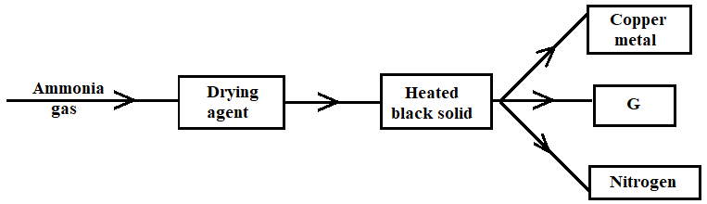

(a) Name a suitable drying agent for ammonia. (1 mark)

………………………………………………………………………………….…………

(b) Describe one chemical test for ammonia. (1 mark)

………………………………………………………………………………….…………

(c) Name G. (1 mark)

………………………………………………………………………………….…………

1. Describe how dry chlorine and hydrogen chloride gases in gas jars can be distinguished using dry blue litmus papers, distilled water and a fume chamber. (3 marks)

……………………………………………………………………………………………………………………………………………………………………………………………………

…………………………………………………………………………………………………

……………………………………………………………………………………………………………………………………………………………………………………………………

…………………………………………………………………………………………………

1. (a) State two factors that accelerate rusting. (2 marks)

…………………………………………………………………………………………………

…………………………………………………………………………………………………

(b) Iron sheets are dipped in molten zinc to prevent rusting. Name this process. (1 mark)

…………………………………………………………………………………………………

1. Given the following substances: wood ash, lemon juice and sodium chloride.

(a) Name one commercial indicator that can be used to show whether rain water wood ash, lemon juice and sodium chloride are acidic, basic or neutral. (1 mark)

…………………………………………………………………………………………………

(b) Classify the substances in 15(a) above as acids, bases or neutral. (2 marks)

|  |  |  |
| --- | --- | --- |
| **Acidic** | **Basic** | **Neutral** |
|  |  |  |

1. Emission of carbon (IV) oxide into the atmosphere has become one of the world’s major concerns.
2. State one disadvantage of releasing carbon (IV) oxide into the atmosphere. (1 mark)

…………………………………………………………………………………………………

1. What causes the level of carbon (IV) oxide in the atmosphere to increase? (1 mark)

…………………………………………………………………………………………………

1. How can the amount of carbon (IV) oxide in the atmosphere be reduced other than avoiding the causes in (b) above? (1 mark)?

…………………………………………………………………………………………………

1. When Xcm3 of 0.5M zinc nitrate solution were reacted with excess ammonium carbonate solution, the mass of zinc carbonate formed was 12.5g.

(a) Write the ionic equation for the reaction that took place. (1 mark)

…………………………………………………………………………………………………

…………………………………………………………………………………………………

(b) Calculate the value of X. (C = 12.0, Zn = 65.0, O = 16.0) (2 marks)

…………………………………………………………………………………………………

…………………………………………………………………………………………………

…………………………………………………………………………………………………

…………………………………………………………………………………………………

…………………………………………………………………………………………………

…………………………………………………………………………………………………

…………………………………………………………………………………………………

1. Below is a sketch of an energy level diagram.

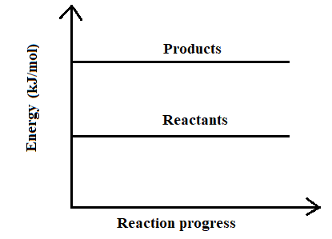

1. On the diagram show the heat of reaction ∆**H.**  (1 mark)

1. State and explain the type of reaction represented by the above energy level diagram. (2marks)

………………………………………………………………………………………………………

………………………………………………………………………………………………………

1. Starting with copper metal describe how a sample of crystals of copper (II) chloride may be prepared in the laboratory (3 marks)

…………………………………………………………………………………………………

…………………………………………………………………………………………………

…………………………………………………………………………………………………

…………………………………………………………………………………………………

…………………………………………………………………………………………………

…………………………………………………………………………………………………

**The Last Printed Page**